МИНИСТЕРСТВО НАУКИ И ВЫСШЕГО ОБРАЗОВАНИЯ РОССИЙСКОЙ ФЕДЕРАЦИИ
Федеральное государственное бюджетное образовательное учреждение высшего образования
«Казанский национальный исследовательский технический университет
им. А.Н. Туполева – КАИ»
Институт компьютерных технологий и защиты информации
Отделение СПО в ИКТЗИ (Колледж информационных технологий)

ЛАБОРАТОРНАЯ РАБОТА №2
по дисциплине

Инженерная компьютерная графика

Работу выполнил
Студент гр.4245
Терехин М.В
Принял
Преподаватель Игонин И.Л.

Казань 2026
Задание №1)
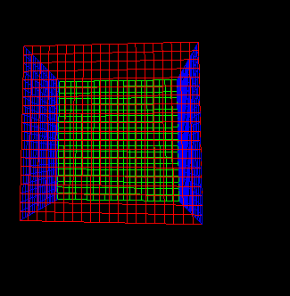
#include <GL/glut.h>
#include <windows.h>

struct vertex3 { GLdouble x, y, z; };
struct color3 { GLdouble r, g, b; };

void DrawLine(vertex3 a, vertex3 b, color3 c) {
glColor3d(c.r, c.g, c.b);
glBegin(GL_LINES);
glVertex3d(a.x, a.y, a.z);
glVertex3d(b.x, b.y, b.z);
glEnd();
}

void DrawGrid(color3 c) {
GLdouble dx = 1.0;
for (int i = -10; i <= 10; i++) {
DrawLine({ i * dx, -10.0, 0.0 }, { i * dx, 10.0, 0.0 }, c);
}
}

void DrawKube() {
glTranslated(0, 0, -30);
glRotated(GetTickCount64() / 100.0, 1, 1, 0); // вращение вокруг X и Y

glTranslated(0, 0, -10);
DrawGrid({ 1,0,0 });
glRotated(90, 0, 0, 1);
DrawGrid({ 1,0,0 });

glPushMatrix();
glTranslated(0, 0, -20);
DrawGrid({ 0,1,0 });
glRotated(90, 0, 0, 1);
DrawGrid({ 0,1,0 });
glPopMatrix();

glPushMatrix();
glTranslated(0, 10, -10);
glRotated(90, 1, 0, 0);
DrawGrid({ 0,0,1 });
glRotated(90, 0, 0, 1);
DrawGrid({ 0,0,1 });
glPopMatrix();

glPushMatrix();
glTranslated(0, -10, -10);
glRotated(90, 1, 0, 0);
DrawGrid({ 0,0,1 });
glRotated(90, 0, 0, 1);
DrawGrid({ 0,0,1 });
glPopMatrix();
}

void display() {
glClear(GL_COLOR_BUFFER_BIT | GL_DEPTH_BUFFER_BIT);
glLoadIdentity();
DrawKube();
glutSwapBuffers();
}

void init() {
glEnable(GL_DEPTH_TEST);
glMatrixMode(GL_PROJECTION);
glLoadIdentity();
gluPerspective(90, 1, 1, 200);
glMatrixMode(GL_MODELVIEW);
}

int main(int argc, char** argv) {
glutInit(&argc, argv);
glutInitDisplayMode(GLUT_DOUBLE | GLUT_RGB | GLUT_DEPTH);
glutInitWindowSize(800, 800);
glutCreateWindow("Вариант 1 – задание 1 (4 грани)");
glutDisplayFunc(display);
glutIdleFunc(display);
init();
glutMainLoop();
return 0;
}

Задание №2)

#include <GL/glut.h>
#include <windows.h>
#include <math.h>

struct vertex3 { GLdouble x, y, z; };
struct color3 { GLdouble r, g, b; };

float anglez = 0, rz = 30;
float ey = 0;

void DrawLine(vertex3 a, vertex3 b, color3 c) {
glColor3d(c.r, c.g, c.b);
glBegin(GL_LINES);
glVertex3d(a.x, a.y, a.z);
glVertex3d(b.x, b.y, b.z);
glEnd();
}

void DrawGrid(color3 c) {
GLdouble dx = 1.0;
for (int i = -10; i <= 10; i++) {
DrawLine({ i * dx, -10.0, 0.0 }, { i * dx, 10.0, 0.0 }, c);
}
}

void DrawKube() {
glTranslated(0, 0, -30);
glRotated(GetTickCount64() / 100.0, 1, 1, 0);

glTranslated(0, 0, -10);
DrawGrid({ 1,0,0 });
glRotated(90, 0, 0, 1);
DrawGrid({ 1,0,0 });

glPushMatrix();
glTranslated(0, 0, -20);
DrawGrid({ 0,1,0 });
glRotated(90, 0, 0, 1);
DrawGrid({ 0,1,0 });
glPopMatrix();

glPushMatrix();
glTranslated(0, 10, -10);
glRotated(90, 1, 0, 0);
DrawGrid({ 0,0,1 });
glRotated(90, 0, 0, 1);
DrawGrid({ 0,0,1 });
glPopMatrix();

glPushMatrix();
glTranslated(0, -10, -10);
glRotated(90, 1, 0, 0);
DrawGrid({ 0,0,1 });
glRotated(90, 0, 0, 1);
DrawGrid({ 0,0,1 });
glPopMatrix();
}

void PressKey(unsigned char key, int, int) {
switch (key) {
case 'a': anglez += 0.1f; break;
case 'd': anglez -= 0.1f; break;
case 'w': rz -= 1; break;
case 's': rz += 1; break;
case 'q': ey += 1; break;
case 'e': ey -= 1; break;
}
glutPostRedisplay();
}

void display() {
glClear(GL_COLOR_BUFFER_BIT | GL_DEPTH_BUFFER_BIT);
glLoadIdentity();

float ex = rz * sin(anglez);
float ez = rz * cos(anglez);
gluLookAt(ex, ey, ez, 0, 0, 0, 0, 1, 0);

DrawKube();
glutSwapBuffers();
}

void init() {
glEnable(GL_DEPTH_TEST);
glMatrixMode(GL_PROJECTION);
glLoadIdentity();
gluPerspective(90, 1, 1, 200);
glMatrixMode(GL_MODELVIEW);
}

int main(int argc, char** argv) {
glutInit(&argc, argv);
glutInitDisplayMode(GLUT_DOUBLE | GLUT_RGB | GLUT_DEPTH);
glutInitWindowSize(800, 800);
glutCreateWindow("Вариант 1 – задание 2 (камера)");
glutDisplayFunc(display);
glutIdleFunc(display);
glutKeyboardFunc(PressKey);
init();
glutMainLoop();
return 0;
}

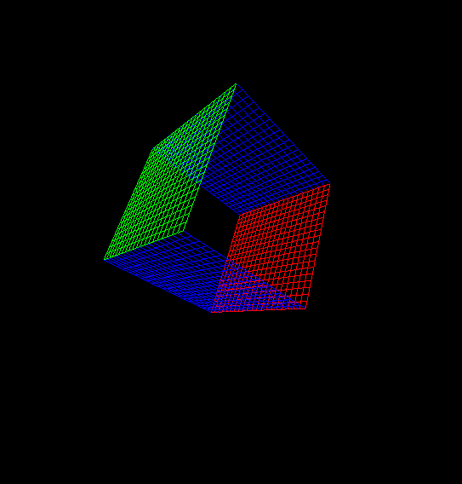

Задание №3)
#include <GL/glut.h>
#include <windows.h>
#include <math.h>

struct vertex3 { GLdouble x, y, z; };
struct color3 { GLdouble r, g, b; };

float anglez = 0, rz = 30;
float ey = 0;

void DrawLine(vertex3 a, vertex3 b, color3 c) {
glColor3d(c.r, c.g, c.b);
glBegin(GL_LINES);
glVertex3d(a.x, a.y, a.z);
glVertex3d(b.x, b.y, b.z);
glEnd();
}

void DrawGrid(color3 c) {
GLdouble dx = 1.0;
for (int i = -10; i <= 10; i++) {
DrawLine({ i * dx, -10.0, 0.0 }, { i * dx, 10.0, 0.0 }, c);
}
}

void DrawKube() {
glTranslated(0, 0, -30);
glRotated(GetTickCount64() / 100.0, 1, 1, 0);

glTranslated(0, 0, -10);
DrawGrid({ 1,0,0 });
glRotated(90, 0, 0, 1);
DrawGrid({ 1,0,0 });

glPushMatrix();
glTranslated(0, 0, -20);
DrawGrid({ 0,1,0 });
glRotated(90, 0, 0, 1);
DrawGrid({ 0,1,0 });
glPopMatrix();

glPushMatrix();
glTranslated(0, 10, -10);
glRotated(90, 1, 0, 0);
DrawGrid({ 0,0,1 });
glRotated(90, 0, 0, 1);
DrawGrid({ 0,0,1 });
glPopMatrix();

glPushMatrix();
glTranslated(0, -10, -10);
glRotated(90, 1, 0, 0);
DrawGrid({ 0,0,1 });
glRotated(90, 0, 0, 1);
DrawGrid({ 0,0,1 });
glPopMatrix();

glPushMatrix();
glTranslated(-10, 0, -10);
glRotated(90, 0, 1, 0);
DrawGrid({ 0,0,1 });
glRotated(90, 0, 0, 1);
DrawGrid({ 0,0,1 });
glPopMatrix();

glPushMatrix();
glTranslated(10, 0, -10);
glRotated(90, 0, 1, 0);
DrawGrid({ 0,0,1 });
glRotated(90, 0, 0, 1);
DrawGrid({ 0,0,1 });
glPopMatrix();
}

void PressKey(unsigned char key, int, int) {
switch (key) {
case 'a': anglez += 0.1f; break;
case 'd': anglez -= 0.1f; break;
case 'w': rz -= 1; break;
case 's': rz += 1; break;
case 'q': ey += 1; break;
case 'e': ey -= 1; break;
}
glutPostRedisplay();
}

void display() {
glClear(GL_COLOR_BUFFER_BIT | GL_DEPTH_BUFFER_BIT);
glLoadIdentity();

float ex = rz * sin(anglez);
float ez = rz * cos(anglez);
gluLookAt(ex, ey, ez, 0, 0, 0, 0, 1, 0);

DrawKube();
glutSwapBuffers();
}

void init() {
glEnable(GL_DEPTH_TEST);
glMatrixMode(GL_PROJECTION);
glLoadIdentity();
gluPerspective(90, 1, 1, 200);
glMatrixMode(GL_MODELVIEW);
}

int main(int argc, char** argv) {
glutInit(&argc, argv);
glutInitDisplayMode(GLUT_DOUBLE | GLUT_RGB | GLUT_DEPTH);
glutInitWindowSize(800, 800);
glutCreateWindow("Вариант 1 – задание 3");
glutDisplayFunc(display);
glutIdleFunc(display);
glutKeyboardFunc(PressKey);
init();
glutMainLoop();
return 0;
}

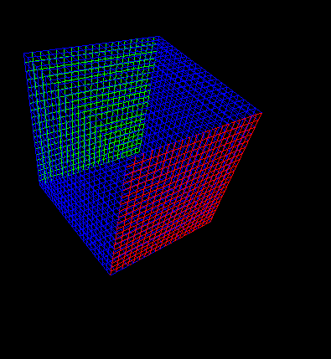

Задание №4)
#include <GL/glut.h>
#include <windows.h>
#include <math.h>

struct vertex3 { GLdouble x, y, z; };
struct color3 { GLdouble r, g, b; };

float anglez = 0.0f, rz = 30.0f;
float ex = 0.0f, ey = 0.0f, ez = 0.0f;
float ax = 0.0f, ay = 0.0f, az = 0.0f;

void DrawLine(vertex3 a, vertex3 b, color3 c) {
glColor3d(c.r, c.g, c.b);
glBegin(GL_LINES);
glVertex3d(a.x, a.y, a.z);
glVertex3d(b.x, b.y, b.z);
glEnd();
}

void DrawRectGrid(vertex3 p1, vertex3 p2, vertex3 p3, vertex3 p4, color3 c) {

int steps = 4;
for (int i = 0; i <= steps; i++) {
double t = i / (double)steps;
vertex3 a = { p1.x + (p2.x - p1.x) * t, p1.y + (p2.y - p1.y) * t, p1.z + (p2.z - p1.z) * t };
vertex3 b = { p4.x + (p3.x - p4.x) * t, p4.y + (p3.y - p4.y) * t, p4.z + (p3.z - p4.z) * t };
DrawLine(a, b, c);
vertex3 c1 = { p1.x + (p4.x - p1.x) * t, p1.y + (p4.y - p1.y) * t, p1.z + (p4.z - p1.z) * t };
vertex3 d = { p2.x + (p3.x - p2.x) * t, p2.y + (p3.y - p2.y) * t, p2.z + (p3.z - p2.z) * t };
DrawLine(c1, d, c);
}
}

void DrawTriGrid(vertex3 v1, vertex3 v2, vertex3 v3, color3 c) {
int steps = 4;

for (int i = 1; i < steps; i++) {
double t = i / (double)steps;
vertex3 a = { v1.x + (v3.x - v1.x) * t, v1.y + (v3.y - v1.y) * t, v1.z + (v3.z - v1.z) * t };
vertex3 b = { v2.x + (v3.x - v2.x) * t, v2.y + (v3.y - v2.y) * t, v2.z + (v3.z - v2.z) * t };
DrawLine(a, b, c);
}

for (int i = 1; i < steps; i++) {
double t = i / (double)steps;
vertex3 a = { v1.x + (v2.x - v1.x) * t, v1.y + (v2.y - v1.y) * t, v1.z + (v2.z - v1.z) * t };
vertex3 b = { v3.x + (v2.x - v3.x) * t, v3.y + (v2.y - v3.y) * t, v3.z + (v2.z - v3.z) * t };
DrawLine(a, b, c);
}

DrawLine(v1, v2, c);
DrawLine(v2, v3, c);
DrawLine(v3, v1, c);
}

void DrawPrism() {

vertex3 v1 = { 0.0, 5.0, -5.0 };
vertex3 v2 = { 5.0, -5.0, -5.0 };
vertex3 v3 = { -5.0, -5.0, -5.0 };

vertex3 w1 = { 0.0, 5.0, 5.0 };
vertex3 w2 = { 5.0, -5.0, 5.0 };
vertex3 w3 = { -5.0, -5.0, 5.0 };

color3 color = { 1.0, 1.0, 0.0 };

)
DrawTriGrid(v1, v2, v3, color);

DrawTriGrid(w1, w2, w3, color);

DrawRectGrid(v1, v2, w2, w1, color);
DrawRectGrid(v2, v3, w3, w2, color);
DrawRectGrid(v3, v1, w1, w3, color);
}

// Управление камерой
void PressKey(unsigned char key, int, int) {
switch (key) {
case 'a': anglez += 0.1f; break;
case 'd': anglez -= 0.1f; break;
case 'w': rz -= 1.0f; break;
case 's': rz += 1.0f; break;
case 'q': ey += 1.0f; break;
case 'e': ey -= 1.0f; break;
}
glutPostRedisplay();
}

void display(void) {
glClear(GL_COLOR_BUFFER_BIT | GL_DEPTH_BUFFER_BIT);
glLoadIdentity();

ex = rz * sin(anglez);
ez = rz * cos(anglez);
gluLookAt(ex, ey, ez, ax, ay, az, 0.0, 1.0, 0.0);

DrawPrism();

glutSwapBuffers();
}

void init() {
glEnable(GL_DEPTH_TEST);
glMatrixMode(GL_PROJECTION);
glLoadIdentity();
gluPerspective(90.0, 1.0, 1.0, 200.0);
glMatrixMode(GL_MODELVIEW);
}

int main(int argc, char** argv) {
glutInit(&argc, argv);
glutInitDisplayMode(GLUT_DOUBLE | GLUT_RGB | GLUT_DEPTH);
glutInitWindowSize(800, 800);
glutCreateWindow("Треугольная призма с сеткой (вариант 1)");
glutDisplayFunc(display);
glutIdleFunc(display);
glutKeyboardFunc(PressKey);
init();
glutMainLoop();
return 0;
}

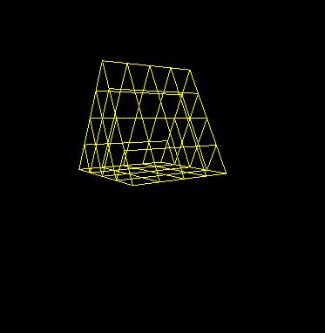
Вывод:
Научился делать разные фигуры в openGl

